For Test Case Ingestion
- Create DB and collection in Mongo DB
- npm install in vs code.
- Convert Excel to JSON by Running = node src/scripts/data-conversion/excel-to-json.js in VS Code. Scripts will run and Test cases uploaded in Mongo DB.
4. Delete All Documents by running the command = node src/scripts/utilities/delete-all-documents.js
For User Story Ingestion
- Create collection in Mongo DB 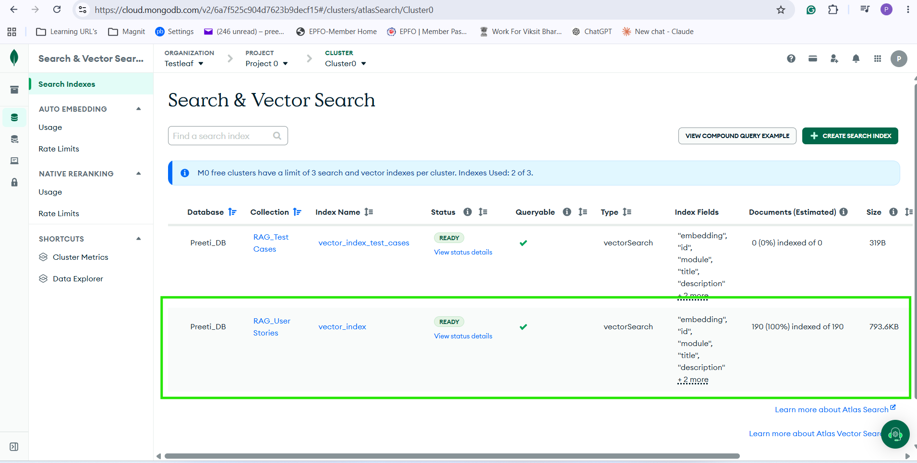
- Convert Excel to JSON by Running = node src/scripts/embeddings/create-userstories-embeddings-batch-mistral.js. 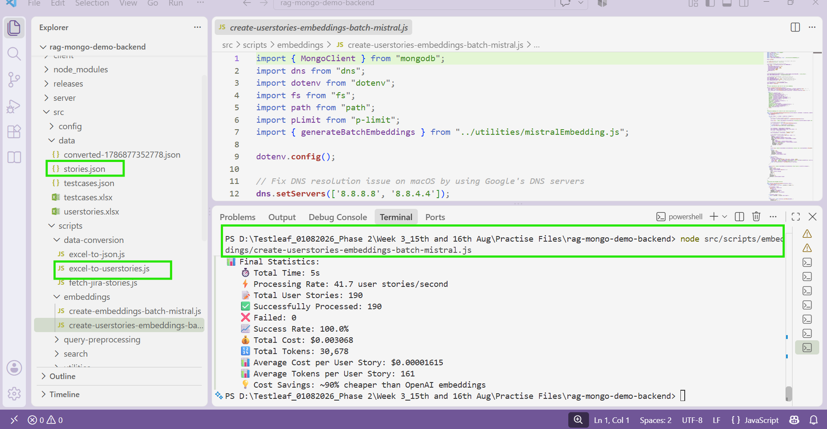
- Verify in MongoDB. 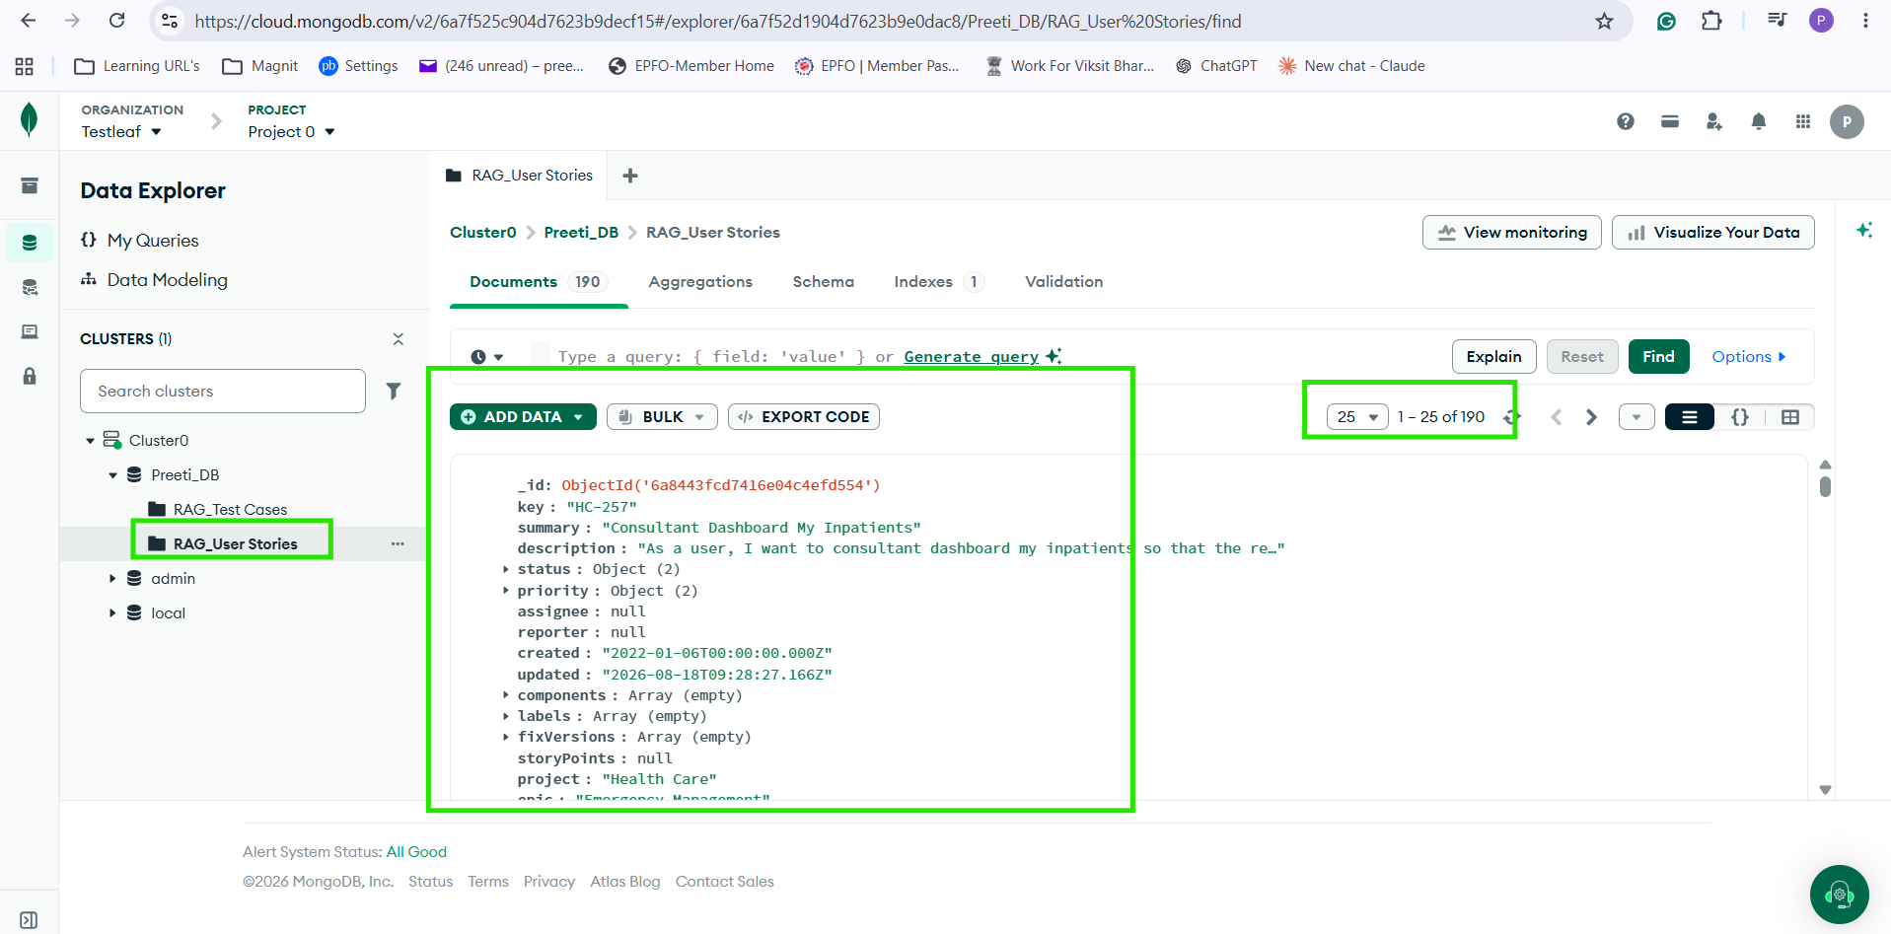
- Delete All Documents by Running the command in vs code
node src/scripts/utilities/delete-all-documents.js
OR 